|  |  |
| --- | --- |
| Assignment Date | 14-11-2022 |
| Team ID | PNT2022TMID48656 |
| Project Name | Iot based  Safety Gadget For Child Safety Monitoring &  Notification |

PROJECT DEVELOPMENT DELIVERY OF SPRINT 2

Technical Architecture

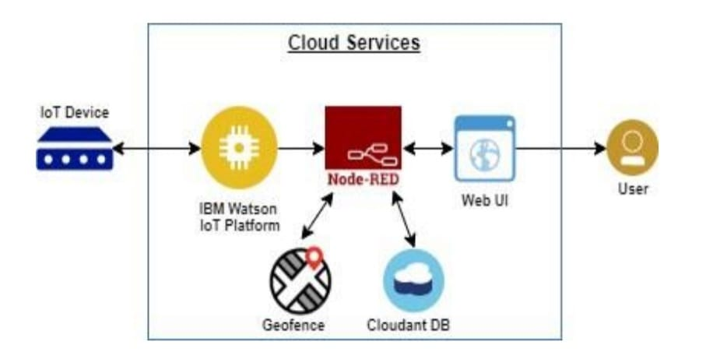**System Architecture diagram of ARCTIC**

* The overall system architecture of ARCTIC contains sensing, processing the datain the cloud using a server and a database, calculating the location information using the retrieved information from the cloud and displaying the distance locally.
* The system architecture diagram for ARCTIC

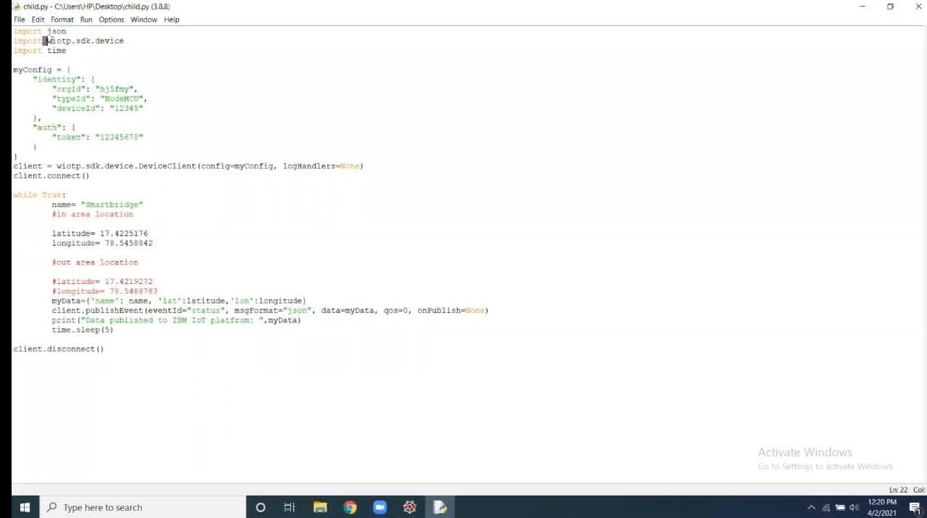

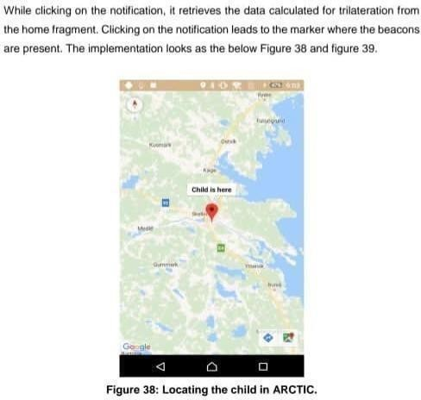

* GPS tracking is a concept where a mobile device is tracked using a Global positioning system. Our system is built on the concept of battery powered asset tracking.
* GPS tracking is a common method to get location information of a user or an asset in real-time planning. GPS tracking system is an open source software and easy to manage user interface viaweb server with Google maps.
* ARCTIC system is implemented with a GPS module, which acquires the location informationof the user and stores it to the database.
* This research demonstrates Smart IOT device for child safety and tracking helping the parents to locate and monitor their children. If any abnormal values are read by the sensor then an SMS is sent to the parents mobile and an MMS indicating an image captured by the serial camera is also sent.
* The future scope of the work is to implement the IOT device which ensures the complete solution for child safety.